**Virtual Reality**

**Brianna Muleski**

**Department of Computer Science**

**University of Wisconsin – Platteville**

**muleskib@uwplatt.edu**

**Abstract**

Virtual reality, an artificial world that consists of images and sounds created by a computer and that is affected by the actions of a person who is experiencing it, is a technology that has been increasingly advancing within the past 50 years. Started as a concept based on 3D, combining 3D immersive space, real time interaction, and self-projection, virtual reality, or VR, has become its own discipline and is growing into its own industry. With the uses of Virtual Reality Modeling Language (VRML) and systems such as scene-graph and distributed virtual reality, the technology is more standardized and reusable than ever before. Products such as the Oculus Rift and Sony’s Project Morpheus have boosted both interest and technology advancement in the past few years, and with their official releases in Q1 of 2016, the technology of virtual reality has only just begun to grow.

**Introduction**

Virtual reality: noun, an artificial world that consists of images and sounds created by a computer and that is affected by the actions of a person who is experiencing it [1]. The technology of virtual reality has advanced substantially in the past few years, and it is only going to get more advanced in the years to come. Virtual reality started as a concept, developed from the technology behind 3D, and has grown into its own industry.

The technology of virtual reality is used in a wide variety of professions and products. From video games to the medical field, virtual reality is changing the way people interact, learn, entertain, and more. For example, Virtual reality is used to help people cope with stress and previous traumas, simulate a dangerous situation in a healthy and safe environment, and interact with worlds that would otherwise be impossible to see.

**History**

**3D to Virtual Reality**

The concept of 3D first appeared in 1838. Sir Charles Wheatstone created the first stereoscope (shown in Figure 1), known as the binocular stereo [2]. The invention was a binocular that used mirrors to project an image that was not in the line of sight for the user. Using this, a picture could be shown to the left eye, and another to the right. When shown together, the image would appear as one image, fused together [3].



Figure 1: Wheatstone Stereoscope

Although the invention of the stereoscope was a major advancement in the technology of the time, and it is the backbone of 3D and virtual reality, 3D as it is known now did not emerge until the early 20th century. 3D essentially has had three “crazes” since the early 20th century, the first one in the 1950s, the second in the 1980s, and the third in the 2010s. Most of the focus of these crazes was within the entertainment industry, specifically the movie industry. Starting in the 1960s, virtual reality followed each subsequent wave of 3D advancement with its own advancements in the 1990s, and an assumed boom of technology in the 2020s [2].

**The Beginning of Virtual Reality**

The first appearance of virtual reality came in the 1960s, following the first craze of 3D. Ivan Edward Sutherland, sometimes referred to as “the father of virtual reality and computer graphics” presented his influential technology in his 1968 paper “A Head-Mounted Three Dimensional Display”. His technology incorporated 3D technology by using computer graphics to create 3D images. He then used these images in the real world. This concept is now known as virtual reality, although that term had not been used yet. The most influential aspect of this technology was the use of computer graphics to create images that could be seen from the perspective of the viewer [2].

By the 1990s virtual reality had advanced to using a head-mounted display. Developed by VPL Research and NASA, the product EyePhone was created in 1989. The EyePhone used alongside a data glove would immerse the user in a virtual reality world. The user could use the data glove to interact with the virtual reality world. This breakthrough technology incorporated the main aspects that we see in virtual reality today: an immersive 3D space, real-time interaction within that space, and self-projection [2].

Although we know all these advancements today as the start of virtual reality, the term “virtual reality” had not been used to describe them. The term was first used in a conference in Santa Barbara in 1990 as a group of researchers and professionals gathered to discuss the advancements and goals of their fields. These conference participants found many similarities across their different fields and devised naming this discipline “virtual reality”, or VR. This conference is sometimes known as the “big bang” that began the first movement of VR and the beginning of the academic field of this discipline [2].

**Today’s Virtual Reality**

**The Technology as We Know It**

Throughout the years, the field of virtual reality advanced to what we see today. Through the uses of 3D graphics, 3D sound and real-time interaction, the user can know fully immerse themselves into a virtual environment and interact with their surroundings. There are essentially two types of virtual reality development frameworks used today: monolithic systems, which group all the tools required to create a virtual reality application in a single package, and scene graph based systems, which use modular architecture to achieve a certain level of flexibility. The difference between these two are simple, their reusability. The problem with monolithic systems is that they lack the ability to be reused and standardized, thus they can only be used to develop a specific virtual reality application. Scene graph based systems are more reusable, meaning they are more advanced and a better solution when creating a virtual reality application [4].

***Scene Graph Based Systems***

A scene graph, an abstract logical access structure, is used to represent the virtual reality environment structure, its objects, and the relationship between those objects. This method is used to create a connection between the main aspects of the virtual reality application: its artificial intelligence systems, its physics, and its animation. There are several implementations of scene graph based programming one of the more popular APIs using this technology is the Java3D toolkit. Java3D is most frequently used to develop web-based applications with virtual reality and real-time 3D graphics. Scene graph based systems use a hierarchical structure to represent the environment and its objects. For example, a game using one of these APIs would represent a section of their environment as follows: a terrain contains a vehicle, the vehicle contains two men, one man is holding a gun and the other man is driving [4]. Each of these would be considered a node. There are three types of nodes in a scene graph system: grouping nodes, children nodes, and attribute nodes [5]. In the above example, the terrain would be a grouping node. The vehicle would be a child node of the terrain and itself is also a grouping node. Both men inside the vehicle are children nodes to the vehicle, and their attribute nodes would be the gun and the man holding the wheel of the vehicle. Figure 2 is a code snippet of the above example [6].

class GroupingNode extends ChildrenNode

{

void AddChildren( ChildrenNode[] a );

void SetChildrean( ChildrenNode[] a);

ChildrenNode GetChildren();

…

}

…

Class Vehicle extends GroupingNode

{

…

ChildrenNode[] GetChildren()

{

return children[];

}

…

}

Figure 2: code snippet of a scene graph node

Although these APIs used the concept in developing the visual accepts of an application, they all still use different languages to design the rest of the application. Using a language designed specifically for virtual reality is a more standard method for creating these applications.

***Virtual Reality Modeling Language***

One of the main aspects of virtual reality modeling language is using the scene graph [5]. Virtual Reality Modeling Language (VRML), sometimes pronounced verml, is one of the most popular languages to accomplish a virtual reality application. VRML is used to design the geometry and interaction functionalities of the application [4]. VRML is widely used with web-based applications such as CAD and online games.

Along with utilizing a scene graph base, VRML has a list of other features that help with creating an effective virtual reality application: event processing, behavior, encapsulation and reuse, distributed content, extensibility, interactivity, and animation. Event processing is the messages sent to and received from the scene graph nodes. The paths/connections used to send and receive messages between these nodes are called routes. These messages, called events, are used to alter the state of these nodes and sometimes are used to start, pause, or end a certain behavior. In addition to the three types of nodes used in the scene graph, there are nodes that contain the behavior of certain aspects of a virtual reality environment. For example, a user in a first-person shooter game shoots a rocket at a building; when the rocket hits the building the building collapses. This functionality would be stored in a node, called a script node. With this type of customized behavior, VRML is able to create and define new node types (prototypes) and reused in different applications. One of the main features of VRML is its uses online, being able to support multiple users inside the same virtual environment. To accomplish this, there are several types of nodes: Inline nodes (hold additional VRML content to be used on demand), Anchor nodes (holds hyperlinks to other URLs), AudioClip nodes (holds audio content, such as wavefile or MIDI, to be used on demand), ImageTexture nodes (holds image content, such as JPEG, PNG, CGM, or GIF, to be used on demand), and VideoTexute nodes (holds video content, such as MPEG, to be used on demand). In addition to the new nodes that can be created within the application, VRML supports the use of external nodes, making the language extensible. This allows a developer use incorporate VRML files in another URL. Sensor nodes, including environment sensor nodes and pointing-device sensor nodes, allow the use to interact with the virtual world, and interpolator nodes are used to create animation supporting objects. Figure 3 describes the interaction of each function in a VRML application [5].

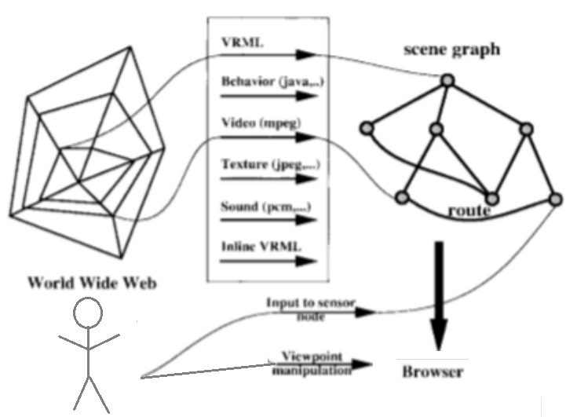

Figure 3: Information flow in VRML file

***Distributed Virtual Reality Systems***

A system that allows users to interact in the same virtual world remotely is called a distributed virtual reality system, or DVR. A DVR system allows several users to interact with the same virtual environment separately and view different aspects of the environment at the same time. This type of system consists of three layers: the user, the software, and the hardware. The user layer is made up of the interface and the view that the each user sees. The implementation and distribution of this layer is hidden from the user. Each user has an associated avatar, which is used to interact with the environment and is completely controlled by the user. This avatar is the representation of the user in the virtual world. The software layer is a collection of software applications (which can be VRML or other languages), interacting with each other to create the virtual world. This layer also includes the client/server application and peer-to-peer application. The hardware layer consists of each user’s PC and the connection to the data network [7]. A DVR system has several features: No global clock and real time performance (all processes interact asynchronously and instantaneously), no shared memory (all user communication is through exchange of messages), geographical separation (all nodes are located in the network, not on each user’s PC), and autonomy (computational nodes are loosely coupled) [8].

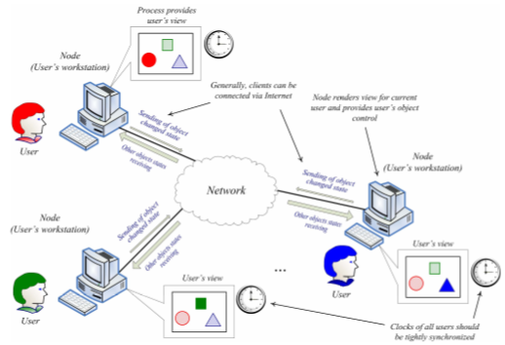

Figure 4: DVR system overview

**Practical Applications**

There are several different industries that are using virtual reality effectively. From using virtual reality to teach medical students how to operate in a safe environment, to treating post-traumatic stress disorder in veterans, to entertaining us, the use of virtual reality is growing every day.

***Entertainment Applications***

Perhaps one of the most popular uses of virtual reality would in the entertainment industry. This can be seen with the number of systems recently created in the gaming industry, such as the Oculus Rift and Sony’s Project Morpheus. However, the gaming industry has been advancing the virtual reality technology since the early 1990’s. In 1991, the world’s first virtual reality “pod” was used in British arcades. The 1000CS was a game system comprised of a game station (the platform a user would use to walk in the game), a Commodore 3000 computer, a head mounted display, and a joystick or controller used as the input device [9]. The 1000CS led to the creation of two very promising VR systems: Oculus Rift and Project Morpheus.

The Oculus Rift is an open platform VR headset (Figure 5h) developed by Oculus VR, an American virtual reality technology company. The founders, Palmer Luckey and Brendan Iribe, created a Kickstarter campaign in August of 2012, which raised a total of $2.4 million and gained a lot of interest. The Oculus Rift works by connecting it to a Windows PC running the Oculus software, which satisfies the minimum system requirements: GPU: NVIDIA GTX 970 or AM 290 or greater, CPU: Intel i5-4590 or greater. The headset is equipped with two OLED panels (one for each eye) with a resolution of 1080x1200 and a refresh rate of 90 HZ (Figure 5f). This means the user will not experience any motion blurring which can be seen with a PC monitor. The headset is also equipped with headphones, developed from RealSpace 3D Audio, allowing for real time spatialized binaural audio [10]. The headset boasts a 100-degree field of view and six-degree-of-freedom head tracking [11]. Alongside the headset, the Oculus Rift uses a positional tracking system made up of infrared LEDs called ‘Constellation’ (Figure 5i) and an input device (an Xbox One Wireless Gamepad or a pair of Oculus’s own controllers called ‘Oculus Touch’ (Figure 5g)). The Oculus Rift uses custom drivers and a runtime service which bypasses the user’s operating system and allows applications to output directly to the headset, allowing the Rift to have high refresh rates and low latency. Oculus also offers a development kit featuring a free SDK for Windows; however OSX and Linux support is planned to be available in the near future. This SDK can be used with existing game engines such as Unity, Unreal Engine, and Cryengine [10]. The Oculus is planned to release Q1 of 2016 and will come in a set with the Oculus Rift, the Oculus Constellation, and an Xbox One Wireless Gamepad (Figure 5e).

It seems the only competition to the Oculus Rift is Sony’s Project Morpheus (Figure 5a), a virtual reality head-mounted display for the PlayStation 4, announced at the 2014 Game Developers Conference. The headset boasts a single 1920x1080 OLED display and a 90-degree field of view [12]. When used with the PlayStation camera (Figure 5c), Project Morpheus can track head orientation and movement of the user. Similar to the Oculus Rift, Sony’s VR headset comes equipped with headphones to allow for 3D stereo audio. The input device used with Project Morpheus would be the already existing PlayStation Move controller (Figure 5b) or the Dualshock 4 (Figure 5d) [11]. Project Morpheus is also set to release Q1 of 2016 [12].

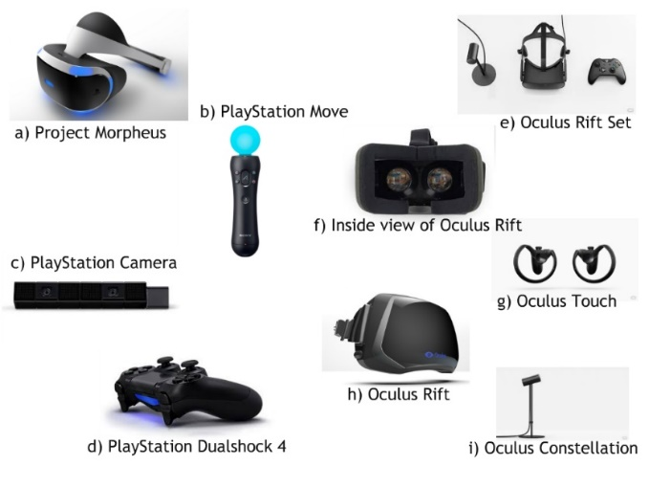

Figure 5: Oculus Rift and Sony’s Project Morpheus

***Medical Applications***

One of the most studied uses of virtual reality in the medical industry is its uses with prolonged exposure therapy to treat issues such as obsessive-compulsive disorder (OCD) and post-traumatic stress disorder (PTSD). Prolonged exposure (PE) therapy involves having the patient immersed in an imaginal reliving and narrative recounting of a traumatic event within a therapeutic setting. This event is repeated several times, each time with a longer time period. It only makes sense that virtual reality would further help immerse the patient in the situation without the negative effects of being in the real situation. Thus, virtual reality exposure therapy (VRET) has gained a lot of traction in the medical community. A 2007 Virtual Iraq/Afghanistan VRET system has been used to treat PTSD and to study the effects of this type of treatment. The treatment consists of exposing the patient to PE for 90 minutes to 120 minutes each weekly session for 10 weeks. The first two sessions do not involve the VR aspect of the therapy. By the third session, a rationale for VRET is introduced and the patient is encouraged to try VRET. If the patient agrees, the patient is immersed in the Virtual Iraq/Afghanistan VRET system for 25 minutes. The fourth session is then conducted with full VRET, and subsequent sessions will involve full VRET as well. Three early case report studies showed the feasibility of the VRET method and the positive outcomes. Two cases following these reported positive outcomes with active-duty soldiers as well. One trial conducted showed a decrease of scores using the diagnostic PTSD checklist-military version from 54.4 to 35.6. This trail included 11 sessions for 20 active-duty service members with an average age of 28 years old [13].

OCD treatments also involve PE therapy and could benefit from the uses of VR in the therapy sessions. According to published controlled studies and meta-analyses, almost 50% of all OCD patients do not respond to the conventional exposure therapy, even when pharmatherapy is added. A study was conducted to research the benefits of using VRET with OCD patients in 2000. The study included 4 women diagnosed with main Axis I OCD; all of their main symptoms were from contamination/washing. Their ages ranged from 22 to 42, none of the women involved had experience with VR before the test, and none of the women were taking medication for their symptoms during the study. Each participant was exposed to four different action sets within the VR environment which involved situations where their OCD symptoms were challenged. The authors of the study found that the patients accepted the use VRET more than the traditional PE therapy [14].

**Possible Future Advancements**

Virtual reality will see a boost of interest and advancements in the next ten years based on the current state of the discipline and the past trends with 3D and VR alike as seen in Figure 6 [2]. With the use of VRML and DVR techniques, virtual reality can only get more efficient and standardized as the technology is studied and tested. The biggest place for advancement in VRML would be compressing the file sizes and therefore decreasing the bandwidth and memory used to run virtual reality applications with VRML files [5]. The biggest place for advancement in DVR would be the consistency of the system and its rendering, the most important being human perception [8]. In terms of the gaming industry, and virtual reality hardware and software in general, advancements will be seen with the release of both Sony’s Project Morpheus and the Oculus Rift.

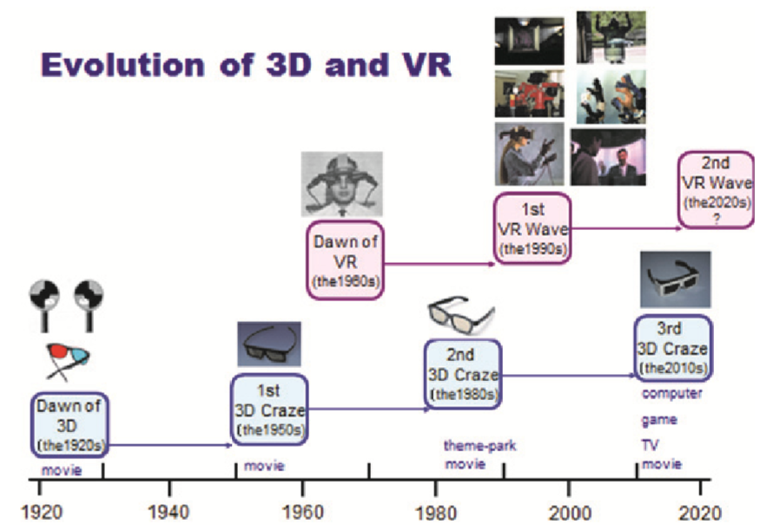

Figure 6: Trajectory of 3D and VR crazes

**Conclusion**

Virtual reality, which started as a concept based on 3D, has advanced significantly since the invention of the EyePhone in 1989. We have seen VR go from an idea, to a discipline, to its own industry over the past 50 years, and it will only continue to grow and change in the years to come. Using VRML and DVR systems to create VR applications, the technology became more standardized and therefore easier to port to other uses.

**References**

1. Virtual reality. (n.d.). *Merriam-Webster*. Retrieved July 29, 2015, from http://www.merriam-webster.com/dictionary/virtual reality
2. Tachi, S. (2013). From 3D to VR and further to telexistence. *Artificial Reality and Telexistence (ICAT), 2013. 23rd International Conference,* 1-10.
3. Stereoscope. (2015). *Wikipedia, The Free Encyclopedia*. Retrieved July 29, 2015, from https://en.wikipedia.org/w/index.php?title=Stereoscope&oldid=655042748
4. Gutierrez, M., Vexo, F., & Thalmann, D. (2006). Standardized Virtual Reality, Are We There Yet? *Cyberworlds, 2006. CW '06. International Conference,*191-197.
5. Taubin, G., Horn, W., Lazarus, F., & Rossignac, J. (1998). Geometry coding and VRML. *Proceedings of the IEEE,* *86*(6), 1228-1243.
6. Van de Wetering, H. (2001). Javra: A simple, extensible Java package for VRML. *Computer Graphics International 2001. Proceedings,* 333-336.
7. Kharitonov, V. (2008). An Approach to Consistent Displaying of Virtual Reality Moving Objects.*Dependability of Computer Systems, 2008. DepCos-RELCOMEX '08. Third International Conference,* 390-397.
8. Kharitonov, V. (2009). A Consistency Model for Distributed Virtual Reality Systems. *Dependability of Computer Systems, 2009. DepCos-RELCOMEX '09. Fourth International Conference,* 271-278.
9. Virtual Reality game station, 1992 - 1994. (n.d.). *Powerhouse Museum,* Australia. Retrieved August 2, 2015, from http://www.powerhousemuseum.com/mob/collection/database/index.php?irn=364729
10. Oculus Rift. (2015). *Wikipedia, The Free Encyclopedia*. Retrieved August 2, 2015, from https://en.wikipedia.org/w/index.php?title=Oculus_Rift&oldid=674035168
11. Avila, L., & Bailey, M. (2014). Virtual Reality for the Masses. *Computer Graphics and Applications, IEEE, 34*(*5),* 103-104.
12. Project Morpheus (virtual reality). (2015). *Wikipedia, The Free Encyclopedia*. Retrieved August 2, 2015, from https://en.wikipedia.org/w/index.php?title=Project_Morpheus_(virtual_reality)&oldid=670888538
13. Rizzo, A., Hartholt, A., Grimani, M., Leeds, A., & Liewer, M. (2014). Virtual Reality Exposure Therapy for Combat-Related Posttraumatic Stress Disorder. *Computer,* *47(7),* 31-37.
14. Belloch, A., Cabedo, E., Carrió, C., Lozano-Quilis, J., Gil-Gómez, J., Gil-Gómez, H. (2014). Virtual Reality Exposure for OCD: Is It Feasible? *Revista de Psicopatologia y Psicologia Clinica, 2014. Vol. 19 Issue 1,* 37.